1. **INTRODUCTION** 
   1. Overview

A brief description about your project

* 1. Purpose

The use of this project. What can be achieved using this. **2Problem Definition & Design Thinking**

2.1Empathy Map

Paste the empathy map screenshot

2.2 Ideation & Brainstorming Map

Paste the Ideation & brainstorming map screenshot

1. **RESULT**

Final findings (Output) of the project along with screenshots.

1. **ADVANTAGES & DISADVANTAGES**

List of advantages and disadvantages of the proposed solution

1. **APPLICATIONS**

The areas where this solution can be applied

1. **CONCLUSION**

Conclusion summarizing the entire work and findings.

1. **FUTURE SCOPE**

Enhancements that can be made in the future.

8. **APPENDI**Source Code

1. Attach the code for the solution built

 Project Report Template

1.**Introduction**

Customer churn is often referred to as customer attrition, orcustomer defection which is the rate at whichthe customers are lost. Customer churn is a major problem and one of the most important concerns forlarge companies. Due to the direct effect on therevenues of the companies, especially in the telecom field,

companies are seeking to develop means to predict potentialcustomer to churn. Looking at churn,different reasons trigger customers to terminate their contracts, for example better price offers, moreinteresting packages, bad service experiences or change of customers’ personal situations.

* 1. **Overview:**

Customer churn has become highly important for companies because of increasing competition among time.

Companies, increased importance of marketing strategies and conscious behaviour of customers in the long.

**1.2 Purpose:**

Customer retention campaigns might be limited to selected customers but it should cover most of the customer. Incorrect predictions could result in a company losing profits because of the discounts offered to continuous subscribers.

**2. Problem Definition & Design Thinking**

The business requirements for a machine learning model to predict whether the customer Will churn or not on customer information, to minimise the number of false positiveschurn which could have stayed loyal. Provide an explanation for the model's decision, forbetter decision making in order to gain more profitability.

**2.1 Empathy Map :**

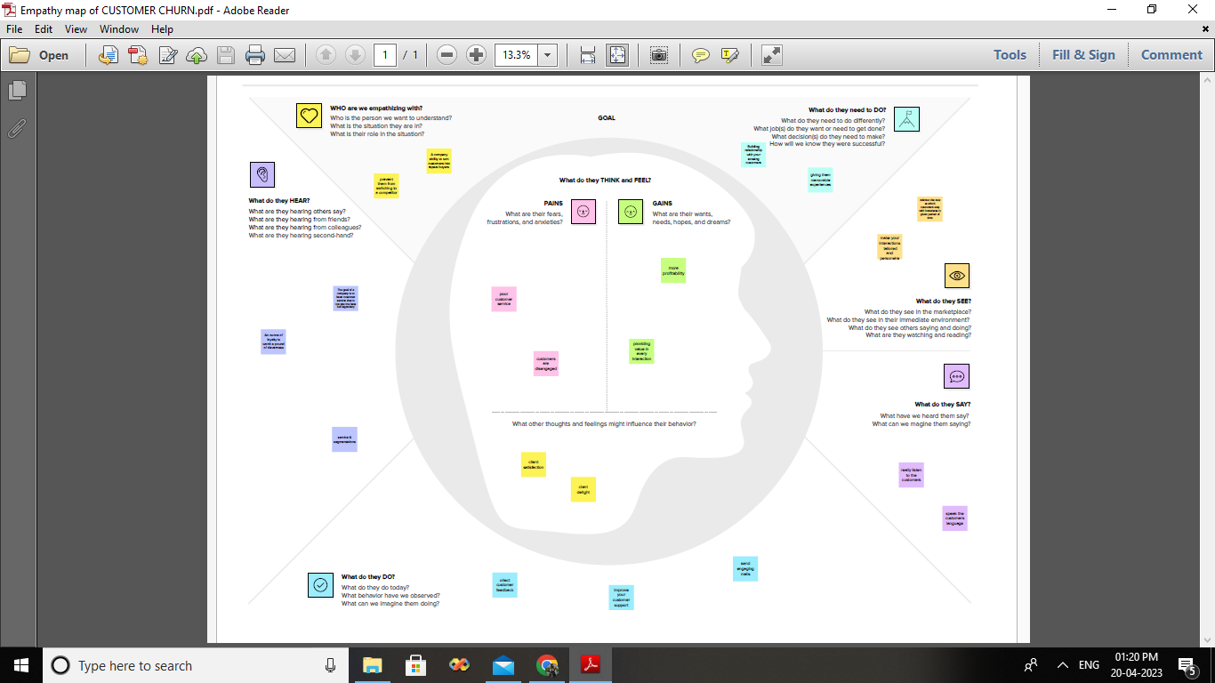

**2.2 Ideation & Brainstorming Map :**

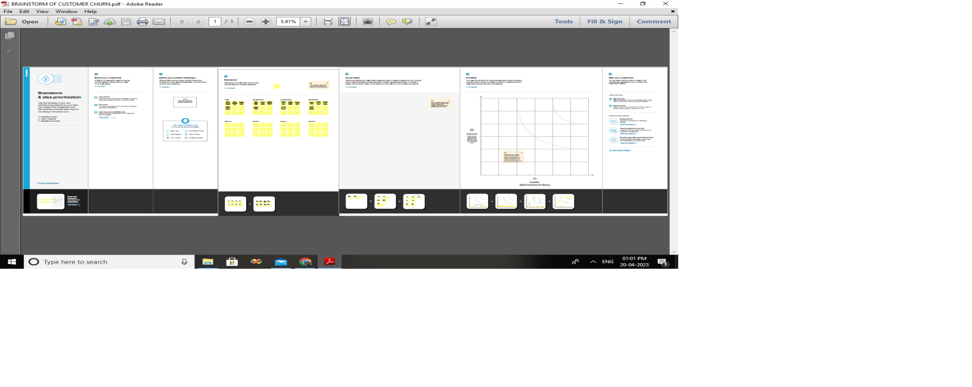

**3.RESULT**

v

**4.ADVANTAGES & DISADVANTAGES**

**Advantages:**

**1.Easily identifies trends and patterns.**

Machine Learning can review large volumes of data and discover specific trends and patterns that would not be apparent to hhuman

**2. Human Resource Information Systems**:

In short, it is also called an HRIS System, and it is used for identifying the best candidates for an open position using machine learning models to filter the applications.

**Disadvantages:**

**1.Data Acquisition**

Machine Learning requires massive data sets to train on, and these should be inclusive/unbiased, and of good quality.

**2. Time and Res**

The data machines process remains huge quantity and differs greatly Machines require time so that their algorithm can adjust to the environment and learn it.

**5. APPLICATIONS**

**Machine learning is a buzzword for today's technology, and it i**

**growing very rapidly day by day. We are using machine learning in our daily life even without knowing it such as Google Maps, Google assistant, Alexa, etc.**

1. **Image Recognition**
2. **Speech Recognition**
3. **Traffic prediction**

**6.CONCLUSION**

**Machine learning is a field of artificial intelligence that deals with the design and development of algorithms that can learn from and make predictions on data. The aim of machine learning is to automate analytical model building and enable computers to learn from data without being explicitly programmed to do so.**

**7. FUTURE SCOPE**

The scope of Machine Learning is not limited to the investment sector. Rather, it is expanding across all fields such as banking and finance, information technology, media & entertainment, gaming, and the automotive industry. As the Machine Learning scope is very high, there are some areas where researchers are working toward revolutionizing the world for the future. Let us discuss them in detail..

**8.APPENDIX**

1. **Source Code**

